**Assignment 2**

**1.**

a.

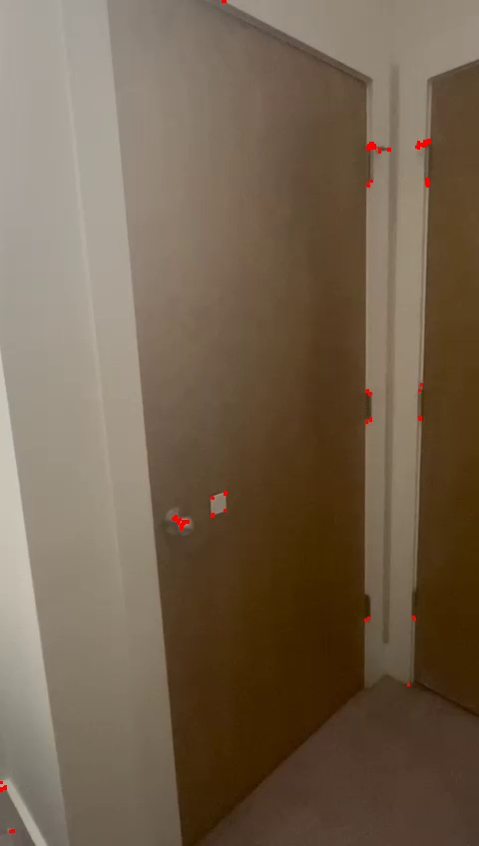

Original Image Harris corner detection

Canny Edge Detection

b.

Homography Matrix

Matching points between two frames

2.

Image 1 Image 2

Image 3 MatLab Stitched Image

3.

Integral Image

4.

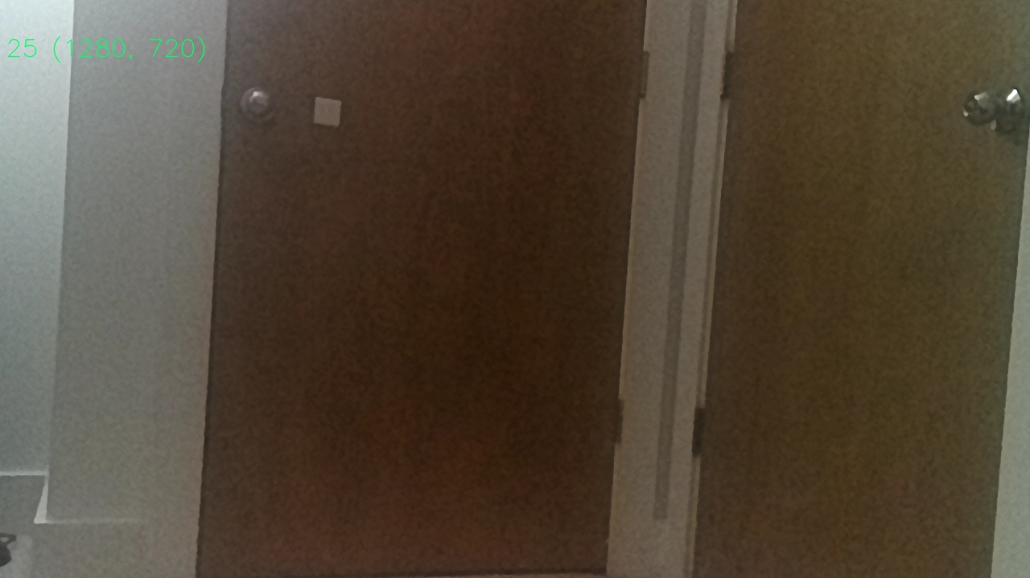 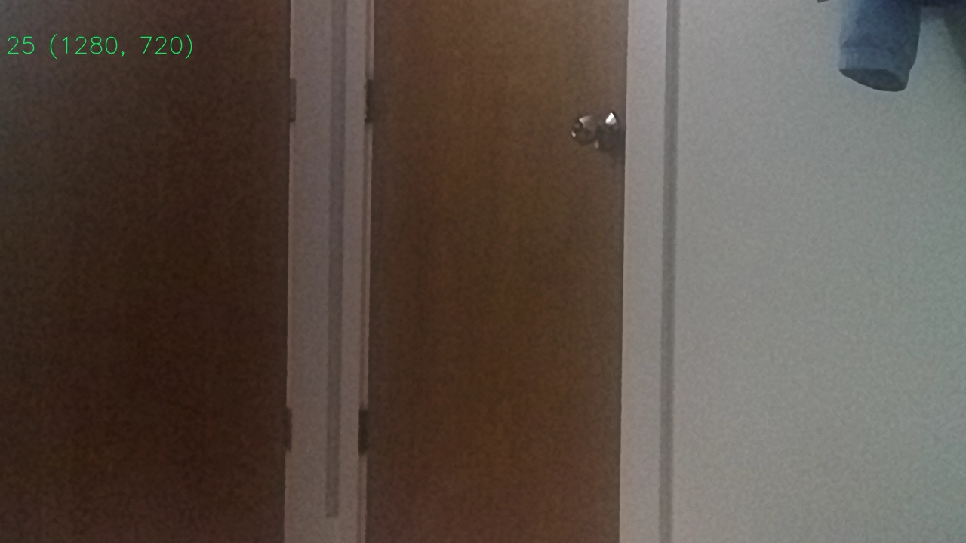

Image 1 Image 2

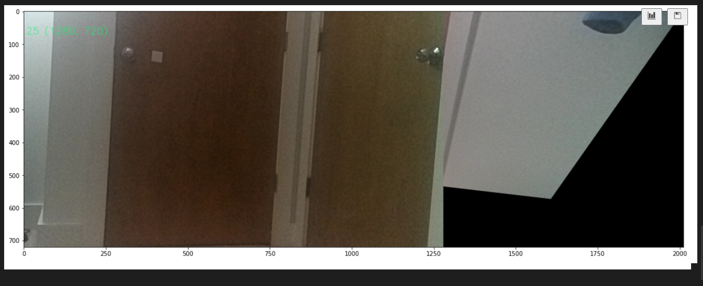

SIFT Stitched Image

5.



ORB Stitched Image